



**MOOCS SEMINAR REPORT**

### Course: BCA

### Student ID: 20041299

### Name: Deepankar Sharma



**Technical University of Denmark (DTU)**

**Environmental Management And Ethics**

[Course link](https://www.coursera.org/learn/environmental-management-ethics)

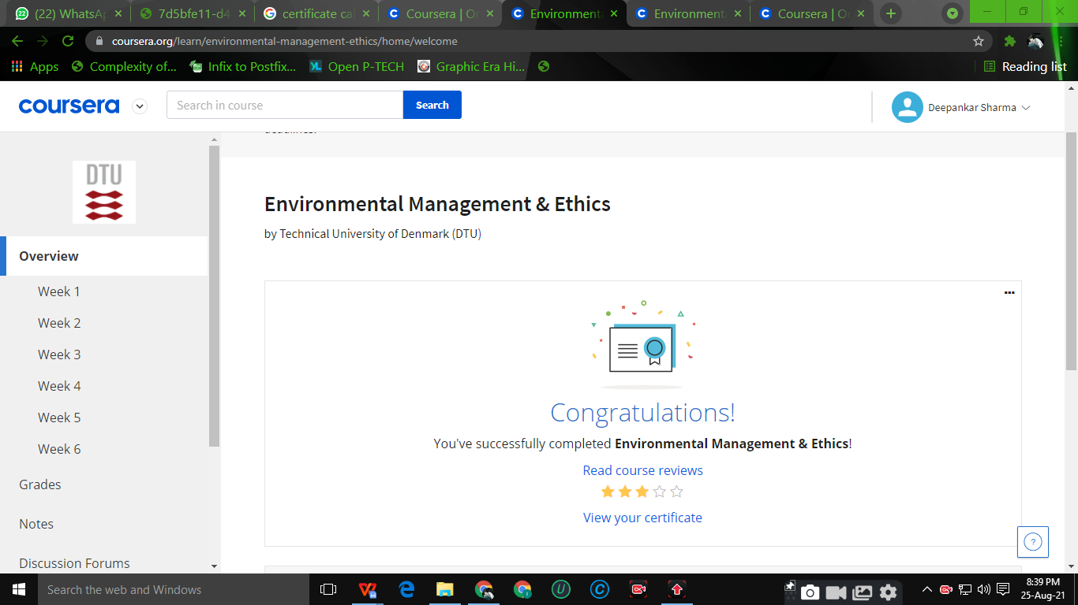

I take this opportunity to express my profound gratitude and deep regards to my teacher Prof. **Mayurika Joshi** **Ma’am**.

For their exemplary guidance, monitoring and constant encouragement throughout the course of this report. The blessing, help and guidance given by them time to time shall carry me a long way in the journey of life on which I am about to embark.

Lastly, I thank almighty, my parents and friends for their constant encouragement without which this project would not be possible.

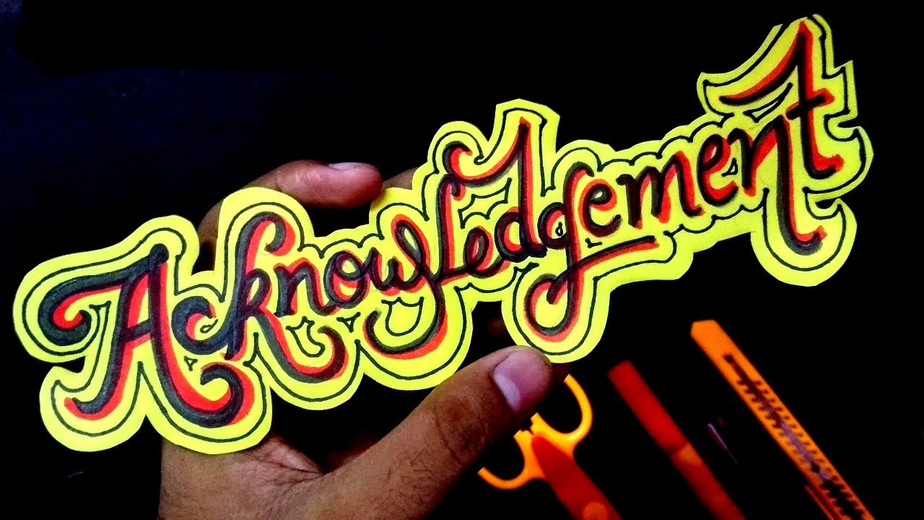



|  |  |
| --- | --- |
| **WEEK** | **NAME OF THE LESSON** |
| **WEEK 1** | Welcome and introduction |
| **WEEK 2** | Environmental ethics |
| **WEEK 3** | Environmental management of wicked problems |
| **WEEK 4** | Decision-support tools |
| **WEEK 5** | Environmental regulation and principles |
| **WEEK 6** | Recommendations on your chosen Environmental ethical dilemma |

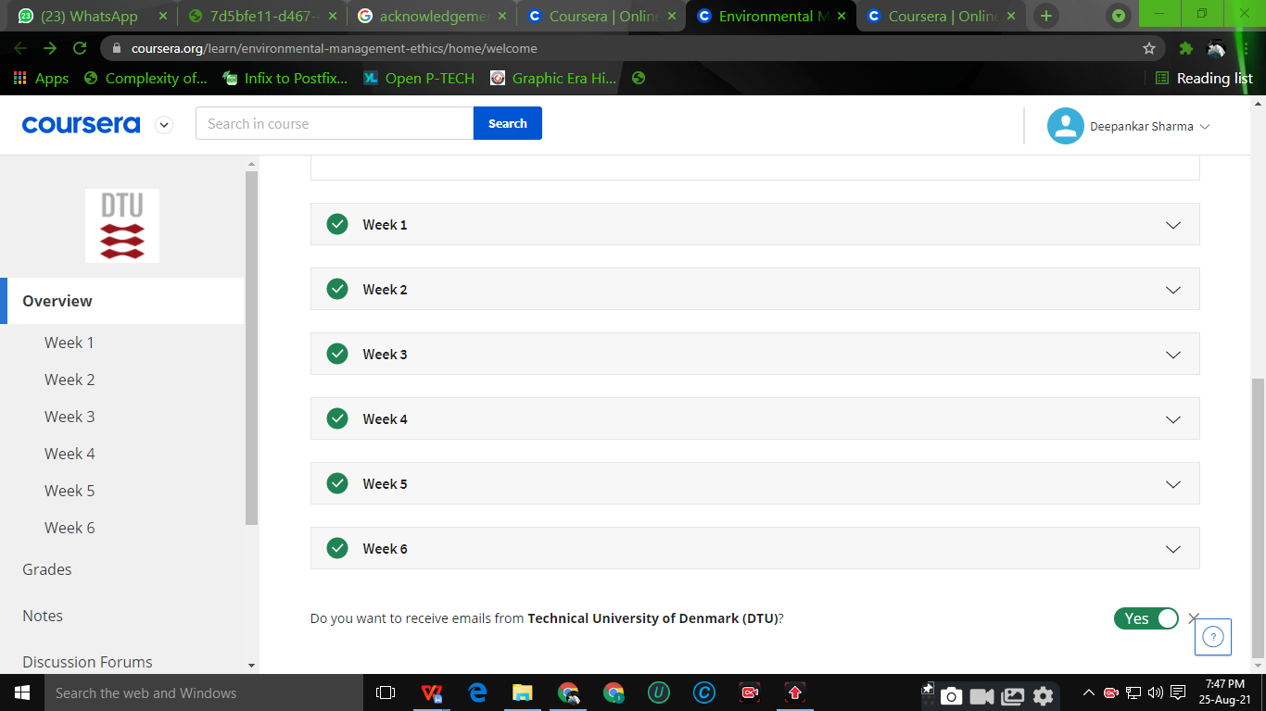



Decision-makers often turn to scientists and engineers to assist them to navigate through complex environmental, health and societal challenges pervaded by systemic uncertainty, ambiguity and ethical implications. This course prepares you to meet the requests and demands of current and future decision-makers and in this course, you will analyze ethical challenges associated with environmental dilemmas and apply different decision making tools relevant to environmental management and regulation.

**Week 01: WELCOME AND INTRODUCTION**

ORIGIN OF EARTH AND EVOLUTION OF THE ENVIRONMENT

The earth broke off about 4.5 billion years ago with an explosion. It was a burning hot white mass of gas and dust. Over a long period of time, dust and gas gradually condensed to form solid rock. Such condensation and shrinking made the earth heat up so much that the rock melted into a gluey liquid.

The environmental ethical dilemmas that we face a immense. In this module, we will introduce you to our course on Environmental Management & Ethics.

**Week 02: ENVIRNMENTAL ETHICS**

In this module, we are introduced to environmental ethics in general and three different kinds of environmental ethics in specific.

**Learning Objectives:**

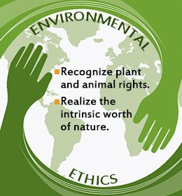

Describe

Define

Summarize

Give examples

* **LAND ETHICS**
* **DEEP ECOLOGY**
* **ECOFEMINISM**

**Week 03: Environmental Management Of Wicked Problems**

In the past, environmental problems were local and we could use our senses to detect them. We could see them, smell them and feel them and we could develop uniform solutions to them. They were tame problems. More and more of the environmental dilemmas and problems that we face are not tame. In this module, you will learn about environmental management of wicked problems in contrast to tame problems.

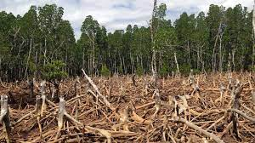

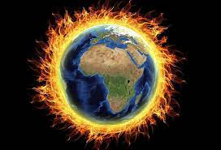

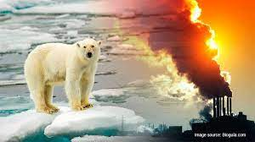

**Week 04: Decision-Support Tools**

Tools and methods such as cost-benefit analysis, risk assessment, technology assessment often provide support to decision-maker when it making decisions about how to best management the environment and environmental resources. These decision-support tools have different ethical foundations and different set of values embedded in them, which are important to have in mind.

* **DPSIR**

DPSIR (drivers, pressures, state, impact and response model of intervention) is a causal framework for describing the interactions between society and the environment: Human impact on the environment and vice versa because of the interdependence of the components.

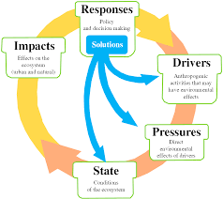

* **COST BENEFIT ANALYSIS**

A cost-benefit analysis (CBA) is the process used to measure the benefits of a decision or taking action minus the costs associated with taking that action.

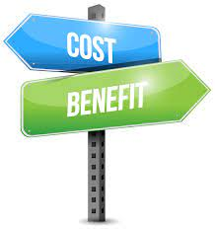

* **STAKEHOLDER ANALYSIS**

Stakeholder analysis is a process of systematically gathering and analyzing qualitative infor- mation to determine whose interests should be taken into account when developing and/or implementing a policy or program.

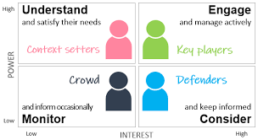



* **TECHNOLOGY ASSESSMENT**

Technology assessment is a scientific, interactive, and communicative process that aims to contribute to the formation of public and political opinion on societal aspects of science and technology.

**Week 05: Environmental Regulation And Principles**

In this module, we were introduced to the main different kinds of implementing environmental regulation as well as some of the key environmental principles on which environmental management is based internationally.



**Week 06: Recommendations On Your Chosen Environmental Ethical Dilemma**

In this module, we learned-by-doing how hard it can be to develop a set of clear recommendation to solve a given environmental ethical dilemma.





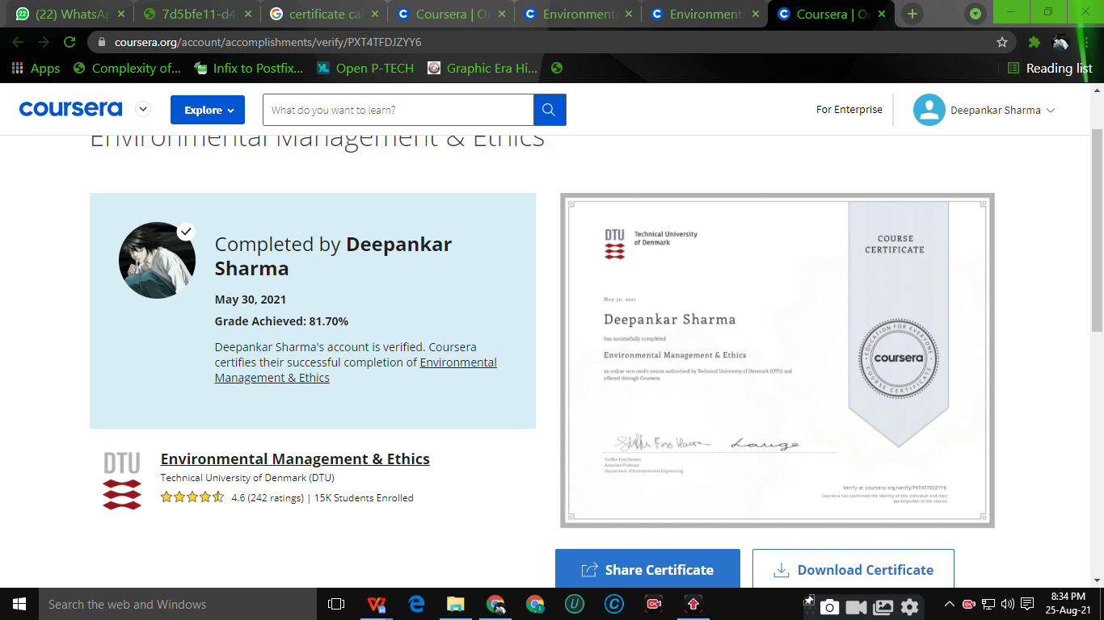

**[click here to verify the certificate](https://coursera.org/share/1e4c7d3af699728b29ac40b02236e3c0)**



Our natural environment makes human life possible, and our cultural environment helps define who we are. It is therefore essential that our population and economic growth are environmentally sustainable. As this essay reveals, environmental education has become a critical issue. In addition to individuals and governmental bodies, associations and learned societies have taken up the cause and published directories and handbooks about environmental education.

Thank You !!!!